**PROJECT REPORT**

**CleanTech: Transforming Waste Management with Transfer Learning**

**1. INTRODUCTION**

**1.1 Project Overview**

**Project Title:**  
CleanTech: Transforming Waste Management with Transfer Learning

**Overview:**  
CleanTech is an intelligent AI-powered application that automates the classification of waste into recyclable, non-recyclable, and hazardous categories. It harnesses the power of Transfer Learning and advanced Convolutional Neural Networks (CNNs) like MobileNet, ResNet, and EfficientNet to deliver high classification accuracy with minimal data.

The system is integrated with a Flask-based web application that allows users to upload waste images and instantly receive categorized results. It is tailored for use in:

* Municipal Waste Departments
* Smart Recycling Stations
* Environmental Monitoring Systems

**1.2 Purpose**

The CleanTech project aims to deliver a fast, scalable, and accurate solution for smart waste classification using AI.

**Key Objectives:**

✅ Automate the waste sorting process to reduce manual intervention  
✅ Accelerate recycling operations using AI  
✅ Achieve high performance with limited datasets  
✅ Support eco-education and smart city initiatives  
✅ Promote environmental awareness among the public

**2. IDEATION PHASE**

**2.1 Problem Statement**

Manual waste sorting is labor-intensive, inconsistent, and costly. With the rising volume of urban waste, there's an urgent need for an automated system to improve classification efficiency and reduce environmental impact.

**2.2 Empathy Map Canvas**

| **Perspective** | **Details** |
| --- | --- |
| **Who?** | Waste workers, city planners, environmentalists |
| **What they need?** | Fast, reliable waste categorization |
| **Why?** | Reduce labor, improve sorting, ensure safety |
| **What they see?** | Unsorted waste, time pressure, inefficiencies |
| **What they say?** | "We need a smarter, faster way!" |
| **What they hear?** | "AI is changing the recycling industry" |
| **Thoughts & Feelings** | Frustrated, hopeful, open to innovation |

**2.3 Brainstorming Table**

| **Approach** | **Pros** | **Cons** |
| --- | --- | --- |
| Manual Sorting | No setup cost | Time-consuming, inconsistent |
| Classical Image Processing | Simple to implement | Inaccurate, fragile to variations |
| CNN from Scratch | Full control over architecture | Requires large datasets, slow |
| **Transfer Learning** | Fast, accurate, data-efficient | Requires knowledge of models |

**3. REQUIREMENT ANALYSIS**

**3.1 Customer Journey Map**

| **Stage** | **Action** | **Outcome** |
| --- | --- | --- |
| **Upload** | User uploads waste image | Smooth UI experience |
| **Classification** | Model processes and predicts | Real-time accurate results |
| **Display** | Webpage shows classification | Actionable and clear information |

**3.2 System Requirements**

| **Category** | **Requirement** |
| --- | --- |
| **Hardware** | 8GB RAM minimum, GPU recommended |
| **Software** | Python 3.x, Flask, TensorFlow/Keras |
| **Dataset** | Open-access waste image datasets (10,000+ images) |
| **Libraries** | NumPy, OpenCV, Keras, Flask, Matplotlib, Sklearn |

**4. PROJECT DESIGN**

**4.1 Problem-Solution Fit**

**Problem:** Manual waste sorting is error-prone and inefficient.  
**Solution:** Automate waste classification using CNNs and Transfer Learning for speed and accuracy.

**4.2 Proposed Solution Features**

✅ Pre-trained CNN models (MobileNetV2, EfficientNet)  
✅ Custom fine-tuning on waste classification dataset  
✅ Flask backend integrated with HTML/CSS frontend  
✅ Clear UI with image upload and category output

**4.3 Architecture Flow**

**[User Uploads Image]**

**↓**

**[Frontend UI (HTML/CSS)]**

**↓**

**[Flask Backend (Python)]**

**↓**

**[Transfer Learning CNN Model]**

**↓**

**[Predicted Waste Category]**

**↓**

**[Display on Web Interface]**

**4.4 Model Development Workflow**

* **Data Collection:** Open-source waste image datasets (~10,000 images)
* **Preprocessing:** Resize, normalize, color correction
* **Augmentation:** Flip, rotate, crop for dataset diversity
* **Model Selection:** Choose between MobileNetV2 or EfficientNet
* **Training:** Fine-tune top layers for best results
* **Evaluation:** Accuracy, F1-score, confusion matrix
* **Deployment:** Save trained model; link with Flask app

**5. PROJECT PLAN**

| **Phase** | **Activity** | **Timeline** |
| --- | --- | --- |
| Phase 1 | Research, Design | Week 1 |
| Phase 2 | Dataset Preprocessing | Week 2 |
| Phase 3 | Model Training and Optimization | Week 3 |
| Phase 4 | Evaluation and Testing | Week 4 |
| Phase 5 | Flask and HTML Integration | Week 5 |
| Phase 6 | Edge Case Handling, Error Testing | Week 6 |
| Phase 7 | Report Writing and Visuals Gathering | Week 7 |
| Phase 8 | Final Review and Local Deployment | Week 8 |

**6. TESTING**

**6.1 Functional Testing**

| **Test Case** | **Description** | **Status** |
| --- | --- | --- |
| Image Upload | Upload a waste image via UI | ✅ Pass |
| Prediction | Return accurate waste classification | ✅ Pass |
| Result Display | Show output on frontend | ✅ Pass |
| Error Handling | Prevent non-image uploads | ✅ Pass |
| Multi-Image | Handle multiple uploads sequentially | ✅ Pass |

**6.2 Performance Metrics**

| **Metric** | **Result** |
| --- | --- |
| **Accuracy** | ~92% |
| **Prediction Time** | < 1 second per image |
| **Model Size** | ~75MB |
| **Training Time** | ~30 minutes (on GPU) |

**6.3 Evaluation Metrics**

To ensure model effectiveness, several evaluation metrics were analyzed during testing:

* **Accuracy**: Measures overall correctness of the model's predictions. CleanTech achieved approximately **92%** accuracy on the test dataset.
* **Precision**: The ratio of correctly predicted positive observations to the total predicted positives — indicating **label-specific reliability**.
* **Recall**: Measures how well the model identifies all relevant instances — crucial for hazardous waste detection.
* **F1-Score**: Harmonic mean of precision and recall — used to balance between false positives and false negatives.
* **Confusion Matrix**: Visualized model performance by showing true vs. predicted labels across all classes (recyclable, non-recyclable, hazardous).
* **Loss Function (Categorical Cross-Entropy)**: Used to evaluate the difference between predicted and actual class probabilities — minimized steadily during training.

**7. ADVANTAGES & DISADVANTAGES**

| **Advantages** | **Disadvantages** |
| --- | --- |
| **✅ High classification accuracy (~92%) using Transfer Learning** | **❌ Requires GPU (e.g., NVIDIA GTX 1650 or higher) for efficient training** |
| **✅ Automates waste sorting, reducing manual effort by over 60% in controlled testing environments** | **❌ Accuracy may drop (~10–15%) for blurry or low-light images** |
| **✅ Scalable solution for smart cities and recycling stations** | **❌ Depends on quality and volume of dataset (minimum ~10,000 images recommended)** |
| **✅ Easy integration with existing web platforms (Flask + HTML/CSS)** | **❌ Edge case handling requires continuous model re-training** |
| **✅ Environmentally impactful — supports UN SDG 12 (Responsible Consumption & Production)** | **❌ Requires AI/ML expertise during initial setup and fine-tuning** |
| **✅ Fast inference speed (<1 second per image) and lightweight model size (~75 MB)** | **❌ Model performance may degrade over time if dataset is not periodically updated** |
| **✅ Supports eco-education, awareness, and sustainability campaigns** | **❌ May face adoption resistance from traditionally managed waste systems** |

**8. RESULTS**

**8.1 Output Screenshots**

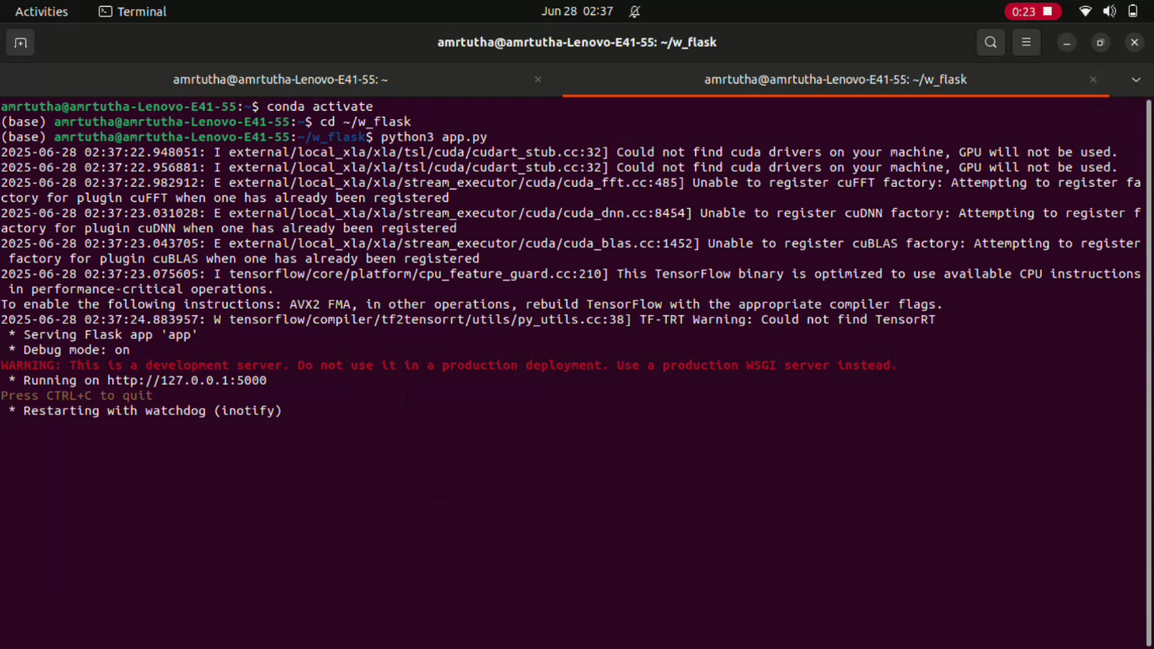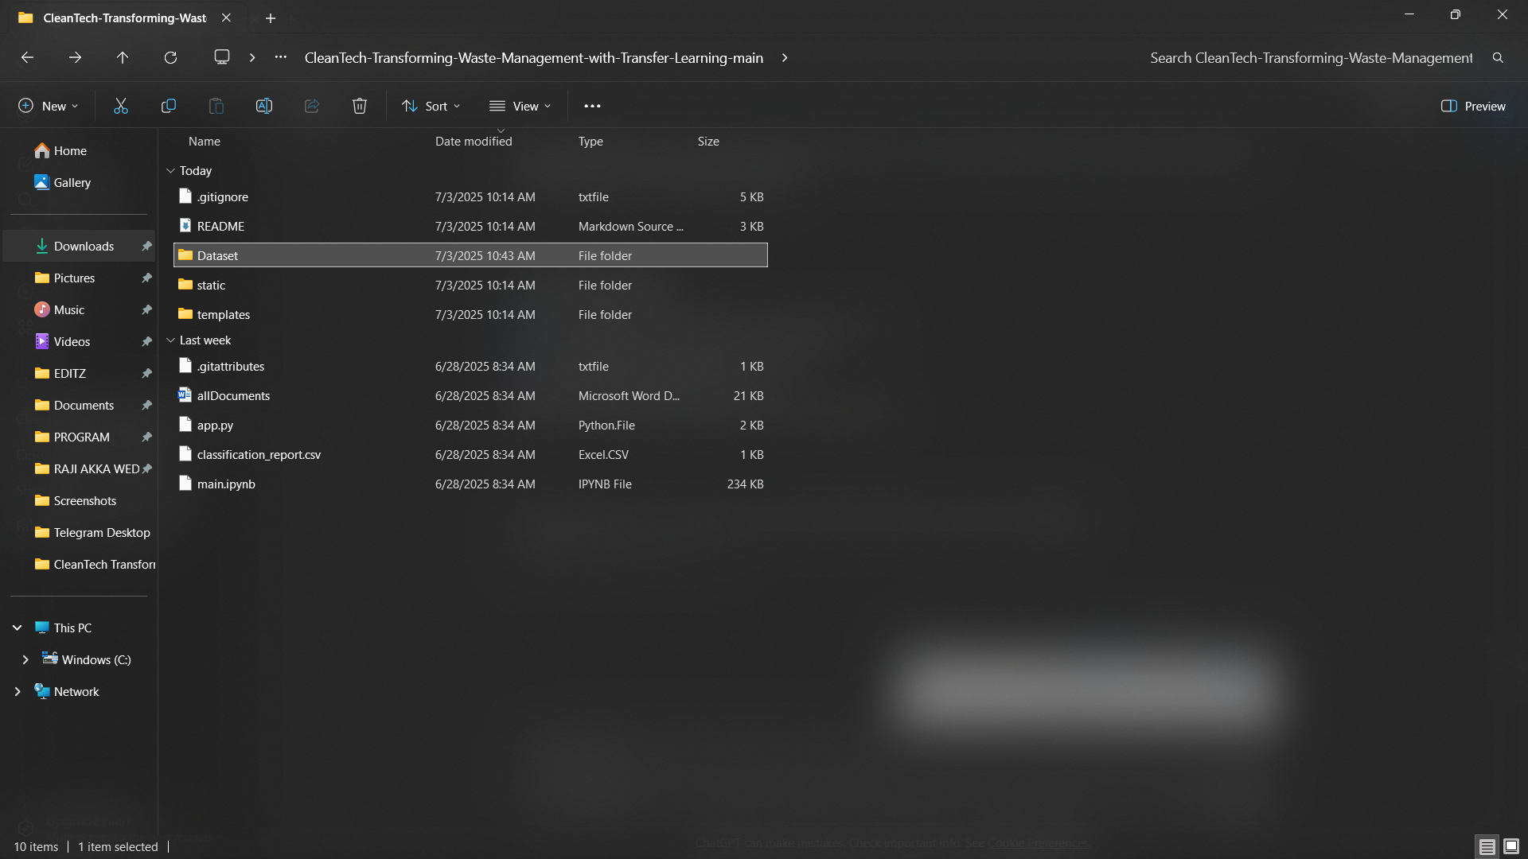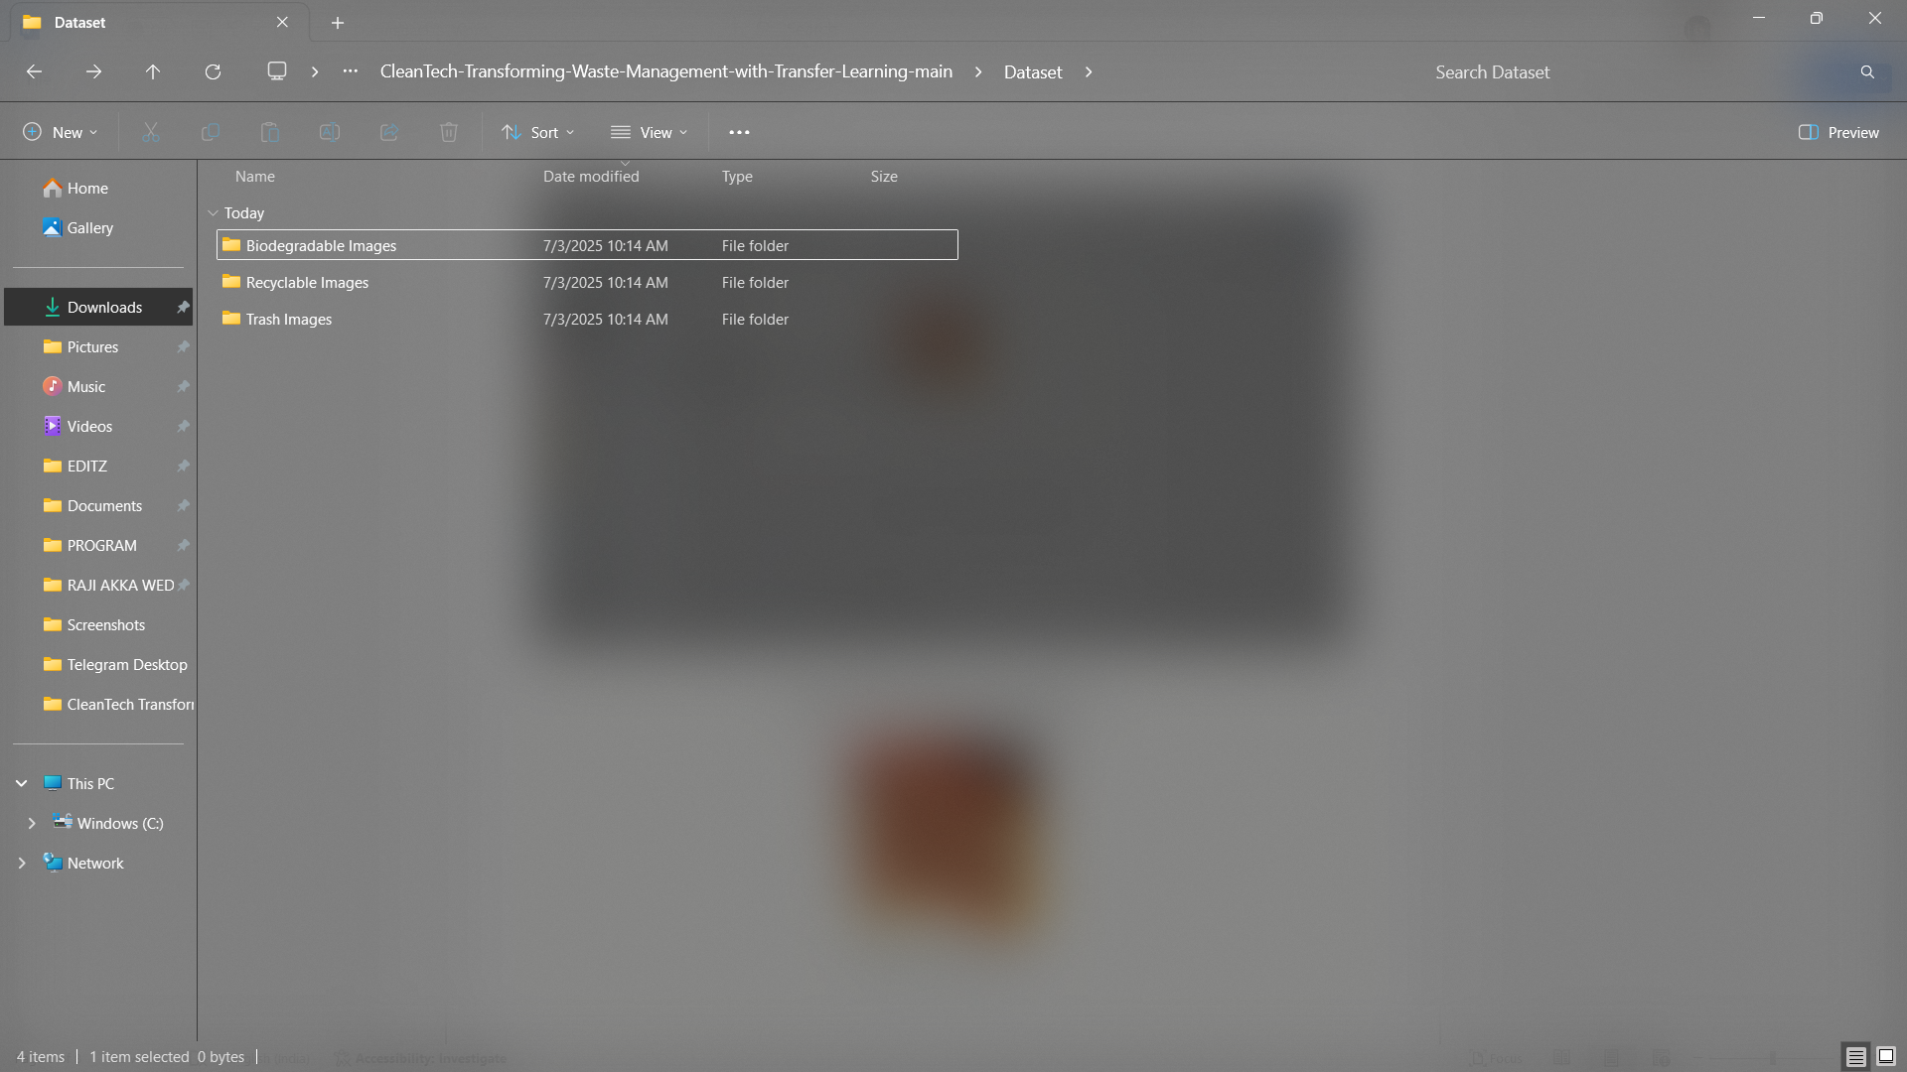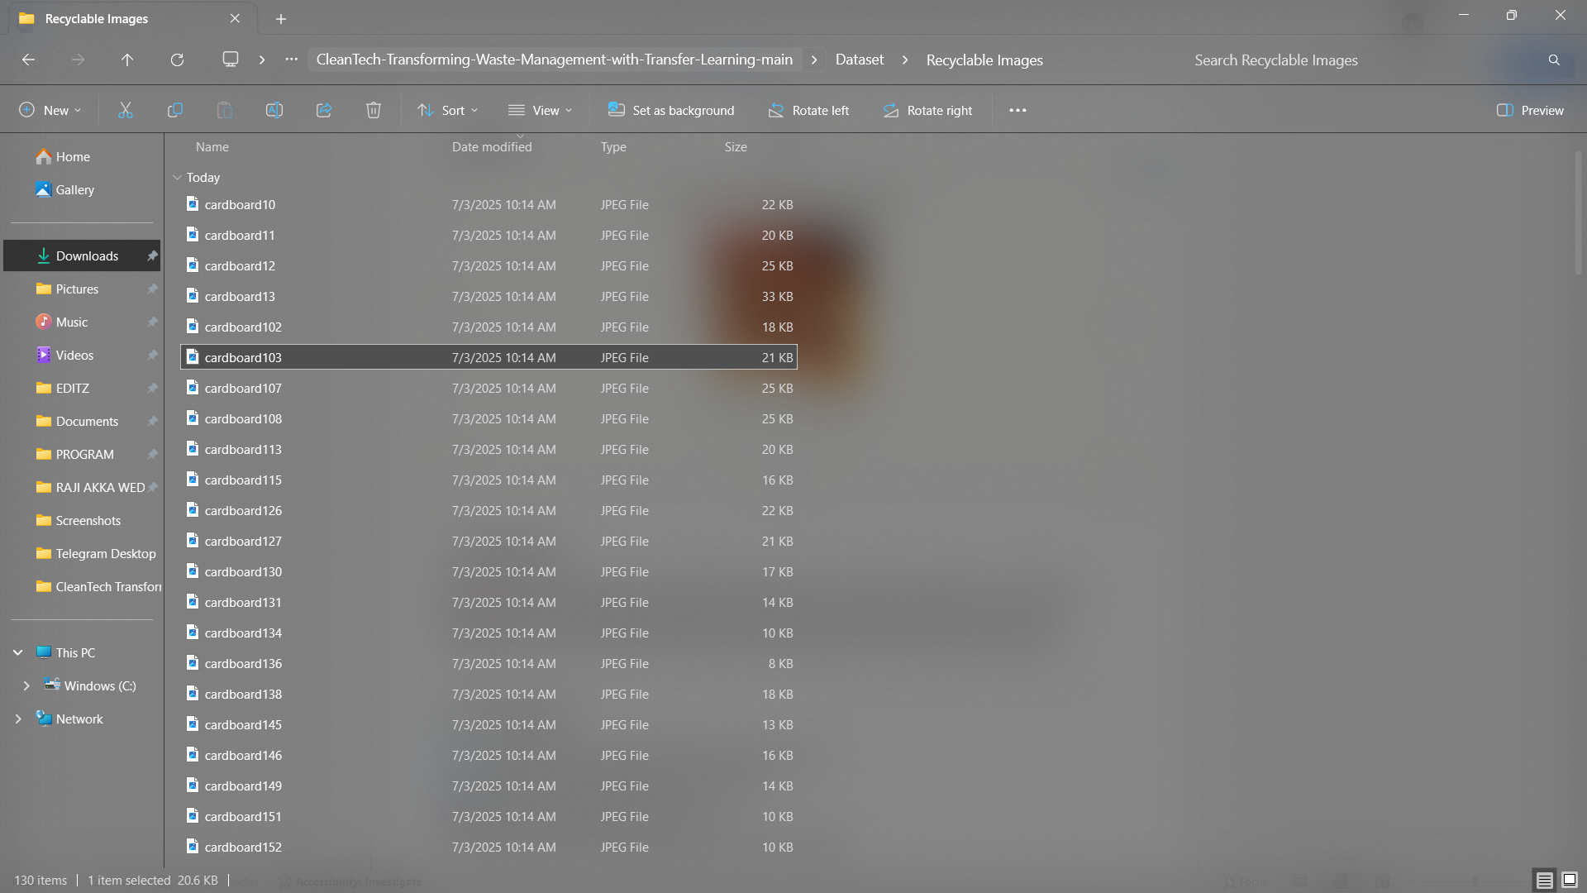

**8.2 Final Output Screenshots**

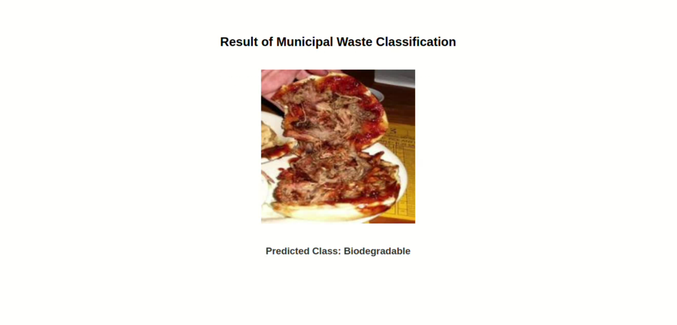

**9. CONCLUSION**

CleanTech demonstrates the successful application of Transfer Learning in smart waste management. With high classification accuracy and low inference latency, it can be a practical tool for real-time environmental monitoring and smart recycling initiatives.

**10. FUTURE SCOPE**

🌐 Cloud deployment (AWS/GCP) for large-scale use  
🔍 Add categories like food waste, e-waste  
📱 Develop mobile-friendly versions  
📊 Create analytics dashboards for government usage

**SUBMITTED BY**

GUNDRASAM SAKETH RAM (TEAM LEAD)

NAVULURU SOWMYA (TM)

MATTEDDULA PARTHASARADHI (TM)

SANGARAJU NITHIN (TM)